**Cron in Magento 2**

* Cron Job is a great feature by Linux, the free operating system for the user.
* The Cron Job will create a command or a script that is appropriate with the task you want to do.
* TheCron Job allows running automaticallyin exact time and date. Due to its automation, the Cron Jobs is the perfect choice for repeated projects every date or every week.
* Cron configuration is very important in Magento to set the schedule for many system activities such as [reindexing Magento 2](https://www.mageplaza.com/magento-2-module-development/magento-2-indexing.html), auto-update of currency rates, Magento emails, etc.
* Only when the configuration is correct, the Cron job is active. In case there is an error, this means Magento won’t function as expected.

**Use of Cron job in Magento 2**

* In Magento store, automated Cron jobs efficiently handle numerous repetitive tasks for maintenance and operation.
* This way will help developers focus on more complex tasks. Here are some specific tasks when you should use Magento Cron Jobs:
* **Sending Newsletter Emails:** Schedule cron jobs to send out newsletters to your subscribers.
* **Indexing and Caching**: Automate the indexing process to update your store data and cache management for optimal performance.
* **Sitemap Generation**: Regularly generate and update your sitemap for search engines.
* **Auto-updates of Currency Rates**: Keep your store’s currency rates up to date with automated updates.
* **Catalog Price Rules**: Apply catalog price rules at set intervals.
* **Customer Alerts/Notifications**: Send out product alerts and stock notifications to customers.

Cron jobs aid ensures these tasks are completed on time without manual intervention, thus saving time and reducing the potential for human error.

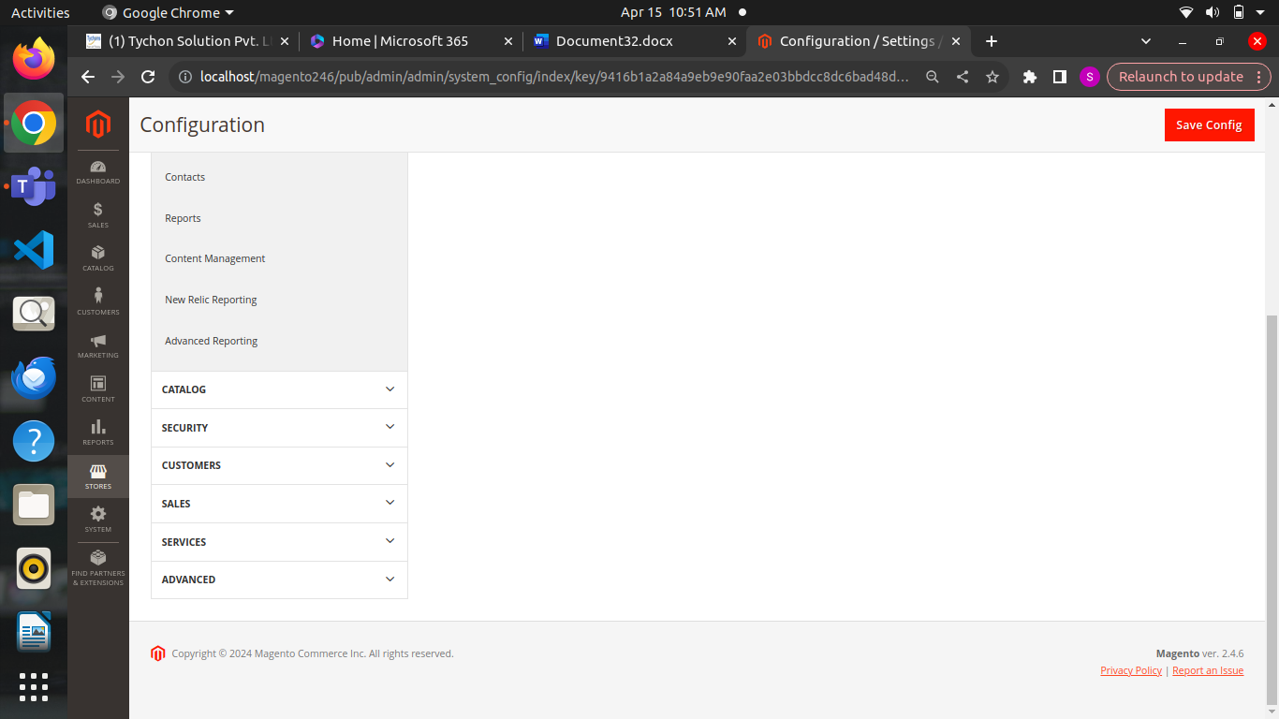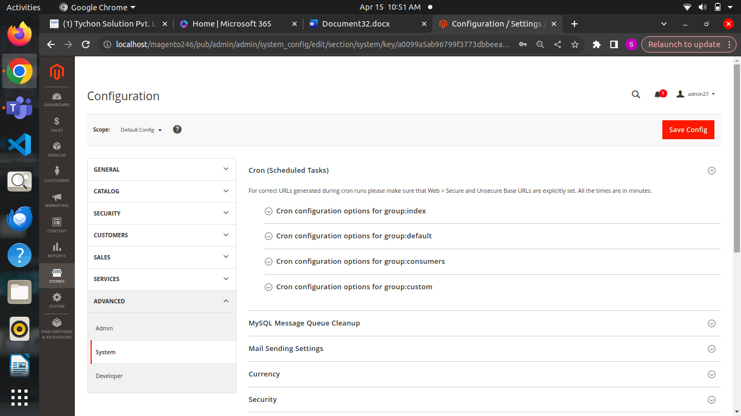

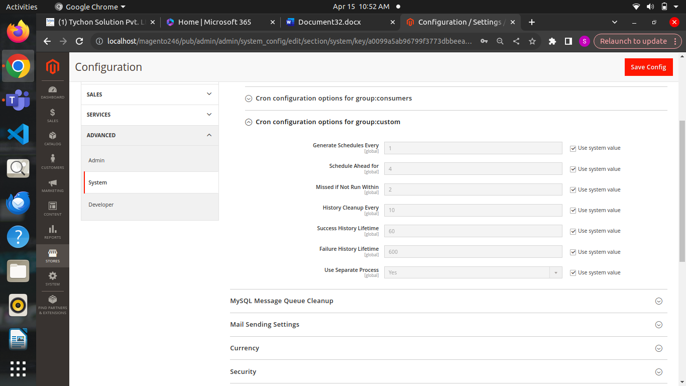

Created custom cron group and executed cron in logger file displayed logger details

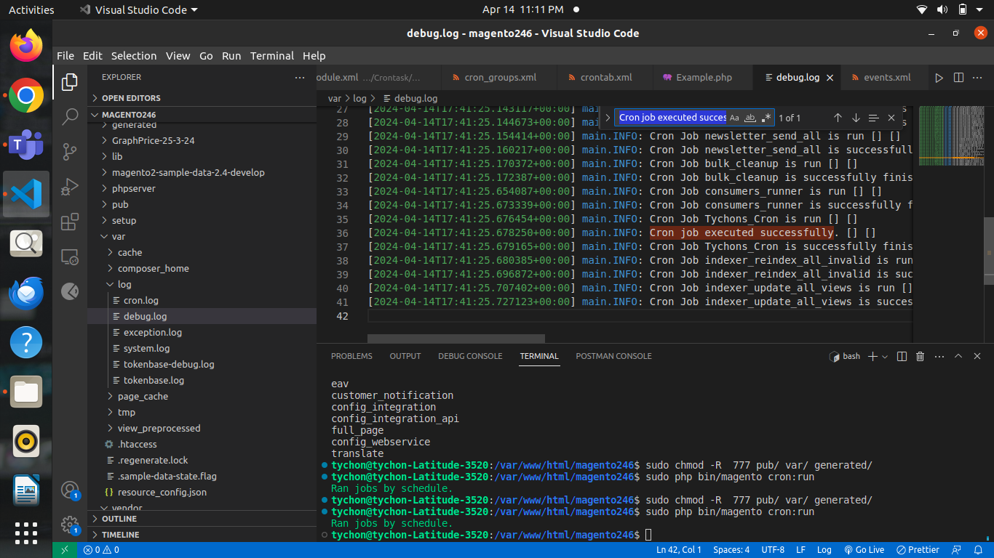

**Order status**

**Create a Custom Order Status**

* Log in to Admin Panel.
* Go to Stores -> Order Status.
* Click onCreate New Status.
* Under the Order Status Information,Fill in up details in the fields.
* Save status.
* Go to Stores -> Order Status.
* Click on Assign Status to State.
* Under the Assignment Information,Select Order Status from the list to assign.
* Select theOrder Stateto include the Order Status which you’ve assigned.
* Check the checkbox Use Order Status as Default, if you want to set it as the default order status.
* Check the checkbox **Visible on Storefront,** if you want to display it at the storefront.
* Go to order status in the order status list and edit the page.
* Customize your order status as per requirement.
* Click on Save Status.
* Delete an order status from the existing state
* Find the order status that you want to unassign in the status list.
* Into the respective row, click Unassign under the Action column.

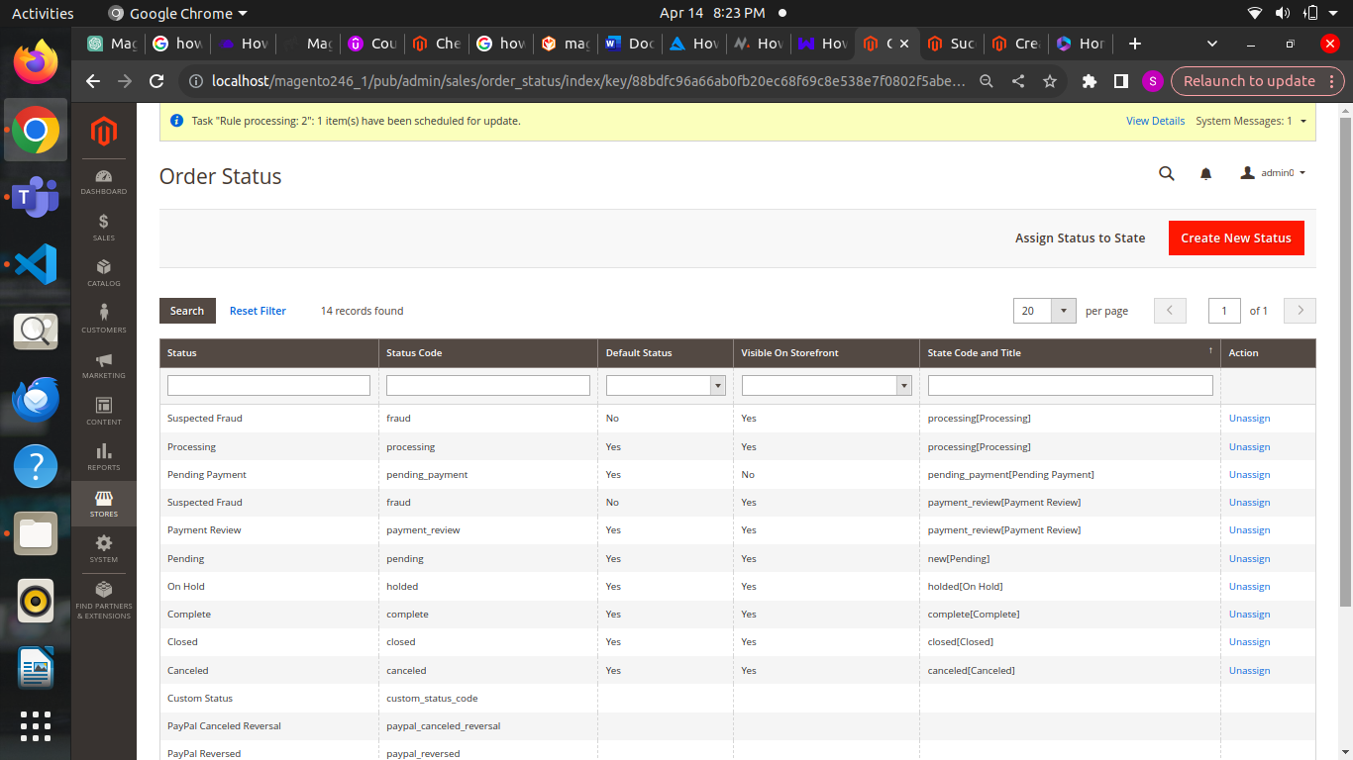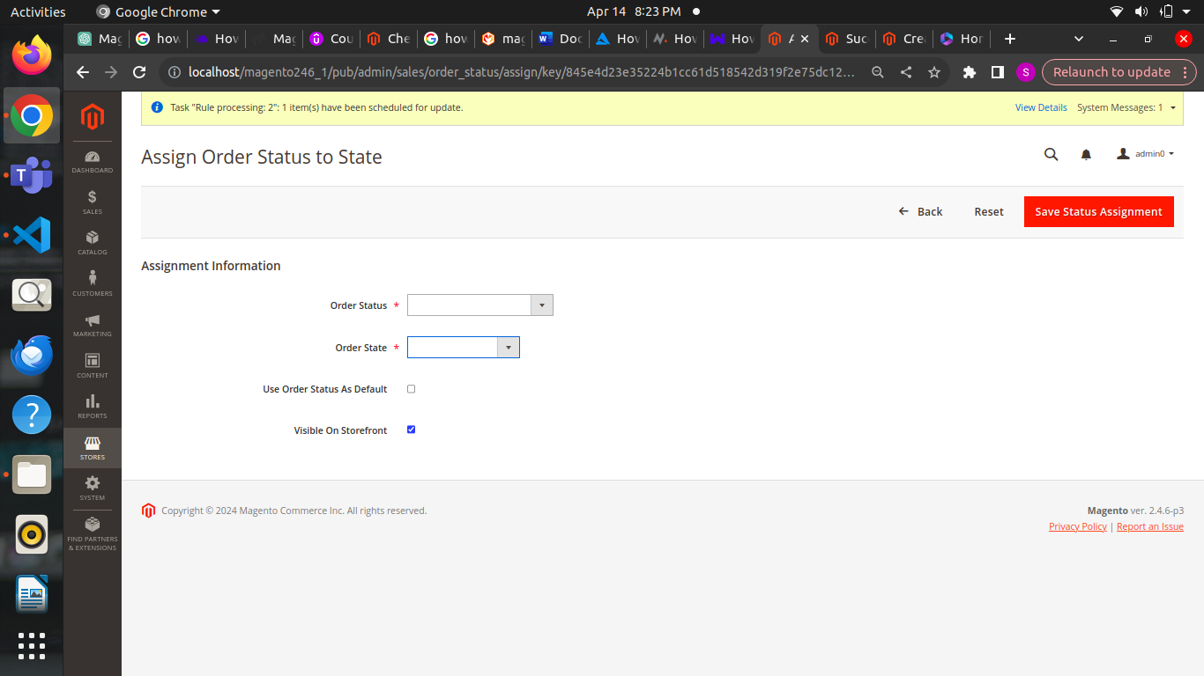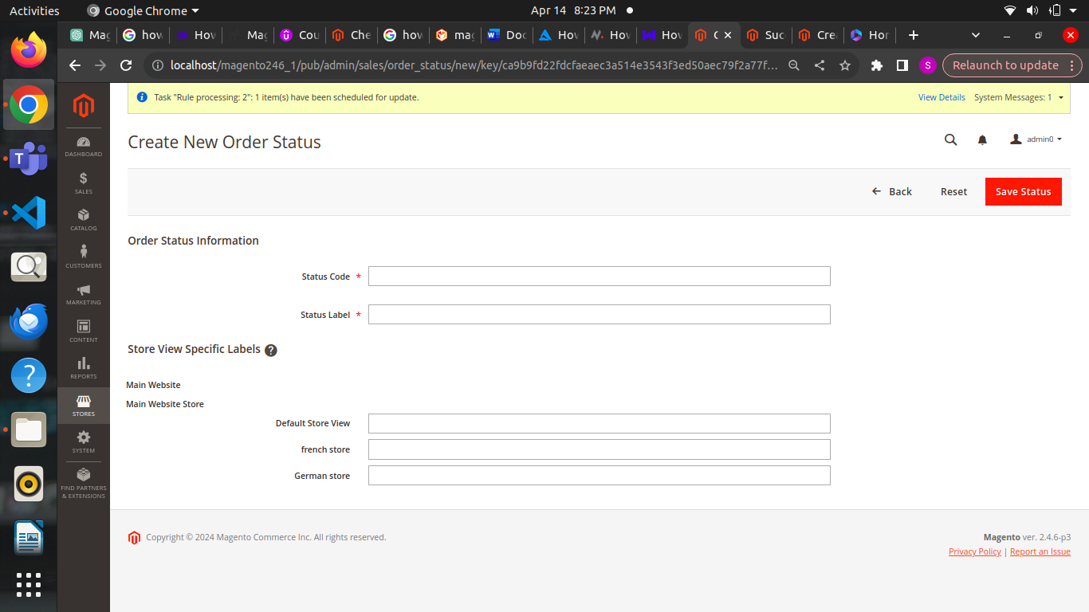

In the module assigned the custom order status when order placed

